1. We made dummy cart actions for testing.

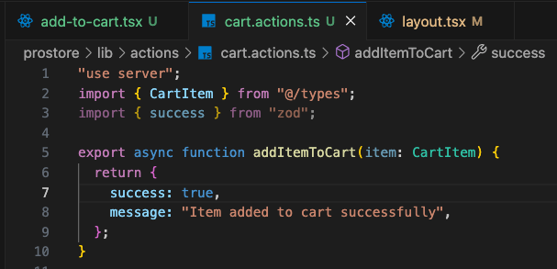

1. Then we made the add to cart component and installed toast from shadcn.

* The toast like we knew is now changed to Sonner



* Then we imported it in our main layout

1. Then used it in our handler function

